Daily Notebook & Social Networking Updater

**MCA 6th Semester**

**MCSP-060 (Project Report)**

**Anirban Nandy**

**Enrollment No-105057536**

# Table of Contents/Index with page numbering

# Introduction/Objectives

## Introduction:

Nowadays social networking is the main trend among us. We like to share whatever is happening with us or around us and follow about others. We want to keep track of every possible thing in our life. Earlier day’s people used to maintain Notebook or Daily Diary to write down about their experiences. Now also we do same things but in different ways. With advent of new technologies we use twitter, facebook instead of maintaining a diary. As all of them are online services we cannot access them without an internet connection and sometimes it takes lots of time to load or query our own posts from the server.

Daily notebook & Social Networking Updater will provide a way to organize our daily notes and status updates for social networking sites. It will allow users to add notes and update it to most popular social networking sites. User can add notes anytime and mark it for update, and then whenever user comes online the pending updates will be uploaded to the destination sites. Users will be able to download the RSS feed of the websites and the Daily notebook & Social Networking Updater will automatically download the feeds and make it available for offline view also. The overview of this software is displayed below in the diagram.

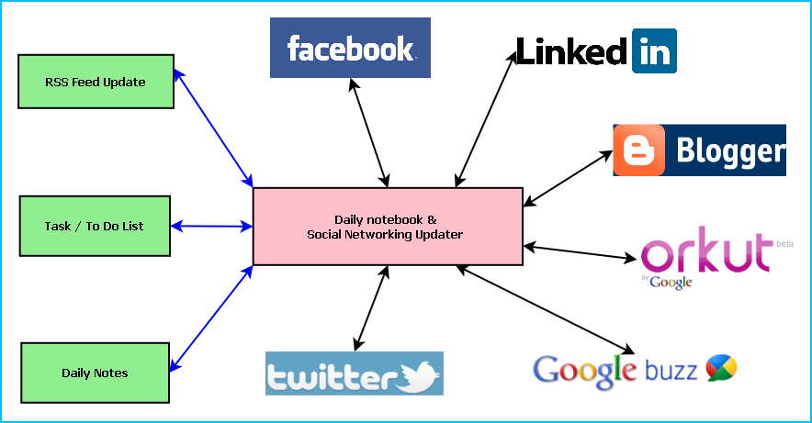

**Figure:** Overview of Daily notebook & Social Networking Updater

Main features of the Daily notebook & Social Networking Updater are:

* Maintaining daily notes
* Updating the status in Social Networking Sites and downloading the RSS feeds

|  |
| --- |
| * Facebook integration * Twitter integration * Google Calendar integration * Linkedin integration * Google plus integration * Google Maps integration |

* Maintaining To Do/Task list
* Reminder/ alarm for scheduled task
* Printing of Notes, To Do & Tasks
* Archiving old data
* Searching Updates

## Objective:

* Single solution for updating any social networking sites
* Keeping track of daily activities
* Timely update whenever internet is available
* To simulate similar experience of Daily notebook.
* To be involved with full-fledged software development
* To know about new technologies like .NET, WPF, Facebook, Twitter.

# System Analysis

## Identification of Need:

I used to write diary regularly ten years ago when I was in school. Today, we use social networking sites as our notebook or diary. Though we can share all our thoughts and memories to the social networking sites, yet there are some drawbacks as well. The main problem is the availability of internet; we cannot share our thoughts while we are at such a place. So we might forget our thoughts. I faced this problem many times. Also, we might not want share all our feelings with others, we could store some of them for ourselves. In that case social networking sites are not as good as a diary or notebook. Sharing same data to different social networking site is a nuisance as we need to do same task repeatedly. I have been facing these problems for many years so I felt that we need a solution that could minimize the drawbacks of social networking sites.

## Preliminary Investigation:

I spoke with many of my friends who use social networking sites regularly and most of them face similar kind of problem. I thought a desktop cum web application could be developed to minimize theses shortcomings of social networking sites. I then started gathering opinion of my friends and seniors among whom some are IT professionals. I gathered all the important points including my own opinion and decided to develop Daily Notebook.

## Feasibility Study:

It is an admitted fact that people are becoming more and more addicted to social networking sites day by day. People would love an application that would make their social networking experience more interesting and flawless. I have decided to provide a password manager that to keep track of the id and passwords created in various websites on the internet. So, undoubtedly it is going to be a popular web cum desktop application.

## Project Planning & Scheduling:

### Gantt chart

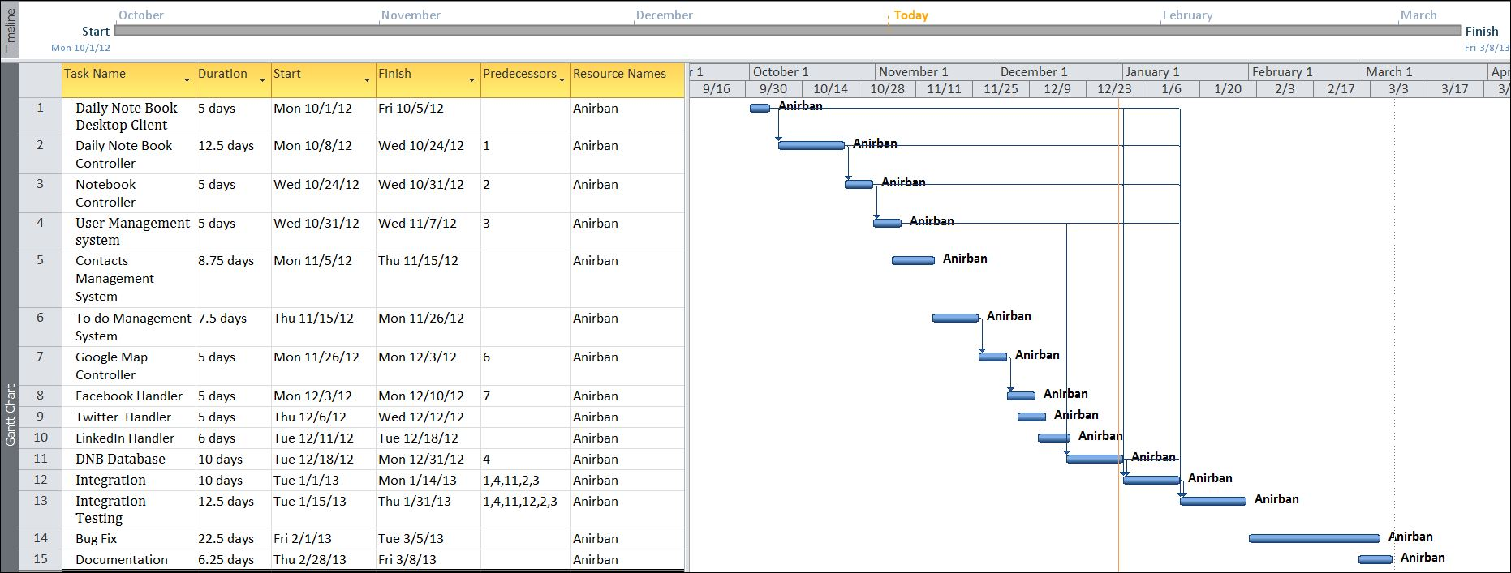

### Tracking Gantt

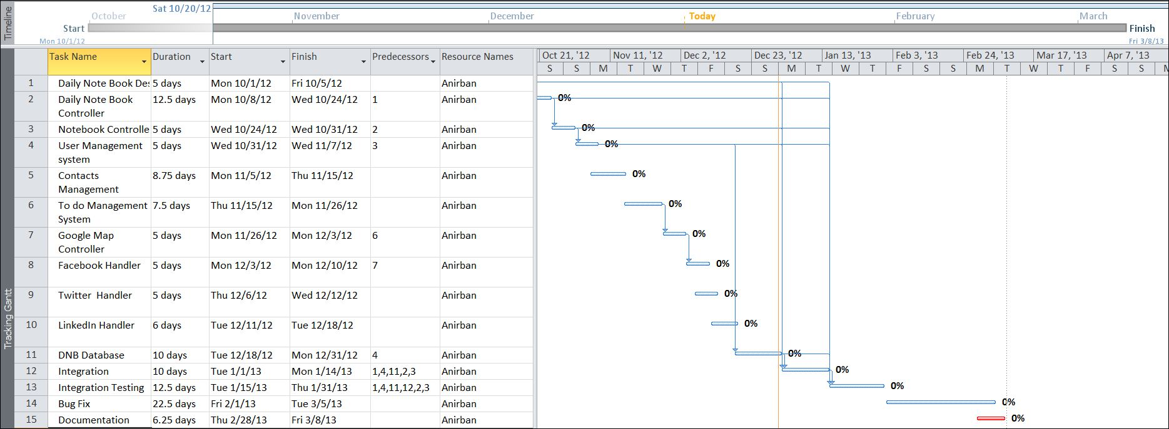

### Pert Chart

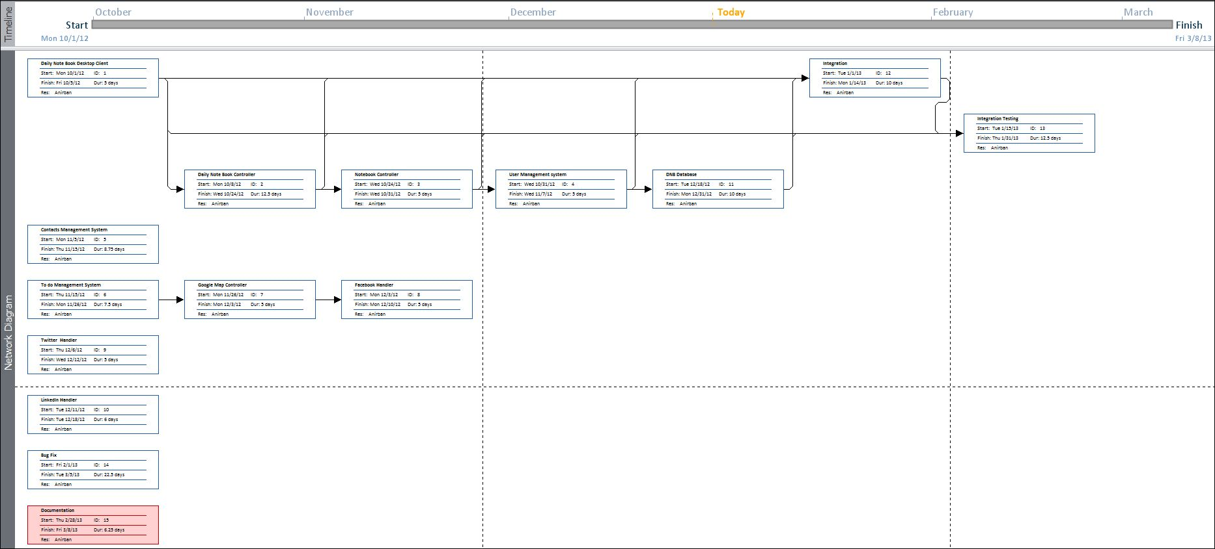

## Software requirement specifications (SRS):

### Minimum System Requirement:

* Windows XP (x86) with Service Pack 3 /
* Microsoft .NET 4.0

### Recommended System Requirement:

* Windows Vista (x86 & x64) with Service Pack 2 / Windows 7 (x86 & x64)

## Software Engineering Paradigm applied

## Data models (like DFD),

### Context Diagram

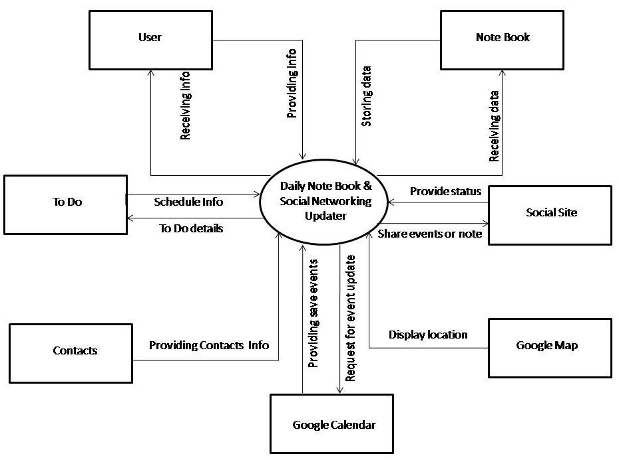

### 0-Level DFD

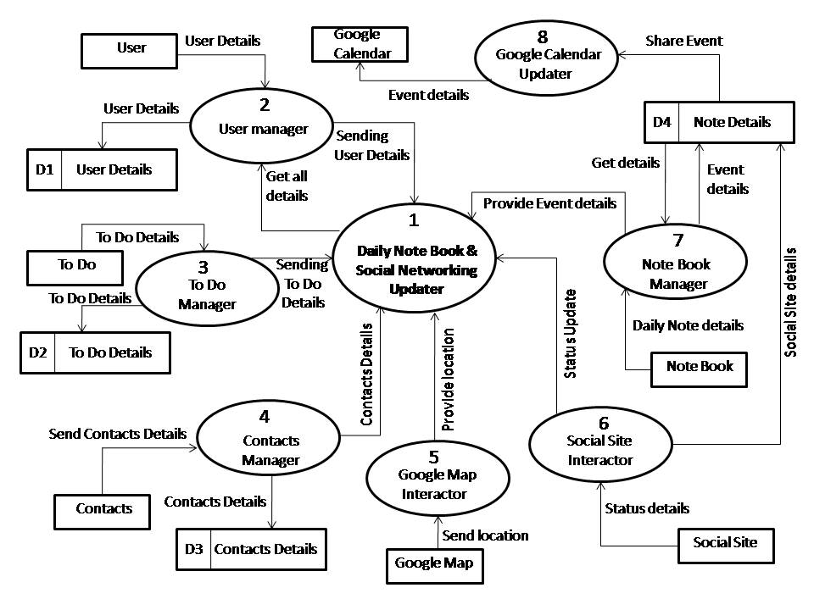

### 1-Level DFD

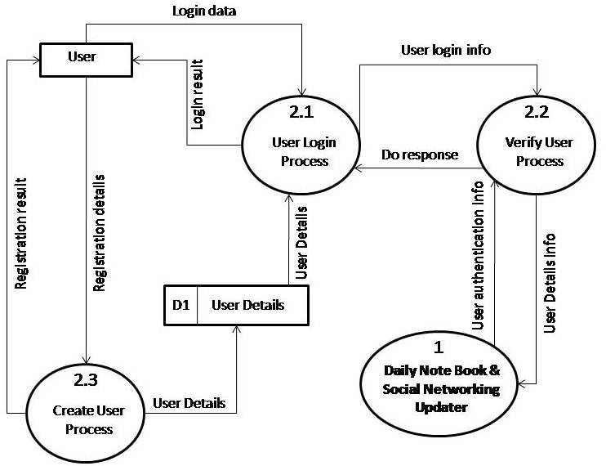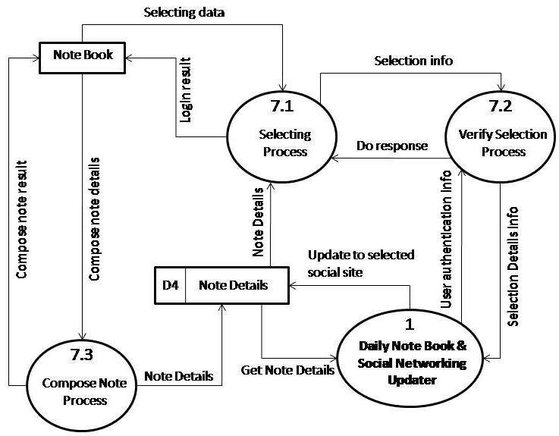

### 2-Level DFD

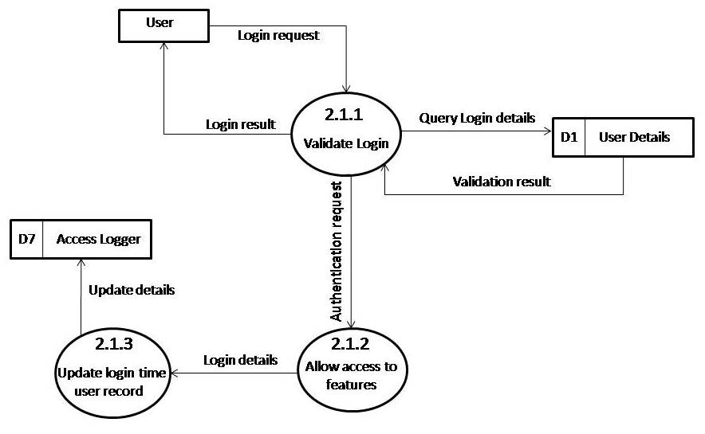

## Control Flow diagrams,

## State Diagrams/Sequence diagrams,

**Interaction Event**

**: Login**

**User**

**: Register**

**User**

**Controller**

**: Update**

**Event**

**: Events**

**Report**

**: View**

**Update Event**

**Report**

**Register**

**Register**

**Modify Expenses**

**Add Event**

**Delete Event**

**Show Error**

**Show Error**

**Show Error**

**Update Event**

**Update Event Report**

**Update Events Report**

**Show Error**

**Show Error**

**Show Error**

**View Report**

**View Event Report**

**Display Event Report**

**Display Report**

**Share Event in Social Site**

**Register**

**Register**

**Update Event**

**Sync Not Complete**

**Sync Complete**

**Sync Event**

**Sync Event**

**Display Event**

**Sync Complete**

**: Login**

**User**

**: Register**

**User**

**Controller**

**: Update**

**Desktop**

**Event**

**: Update**

**Web**

**Application**

**:Update**

**Desktop**

**Application**

## Entity Relationship Model,

We will design a RDBMS for Daily notebook & Social Networking Updater. The entities and their attributes are listed below. Attributes in Bold letter is the unique key.

|  |  |
| --- | --- |
| **Entities** | **Attributes** |
| Note | **Note Id**, Content, Time, Size, Web Service id, user |
| RSS Feed | **RSS Feed Id** , Web Service Id, Content, time, size |
| Daily notebook & Social Networking Updater | **Sw Id**, Web Services Supported, Users, Size |
| User | **User Id**, Name, Social Network Data, Preferences. |
| Web Service | **Web Service Id,** Authentication Data, Feed Data, Preferences. |

**Relationship between Entities:**

* Daily notebook & Social Networking Updater has User 🡪 1 : N
* Users post Notes 🡪 1 : N
* Web Service generates Feeds 🡪 M : N

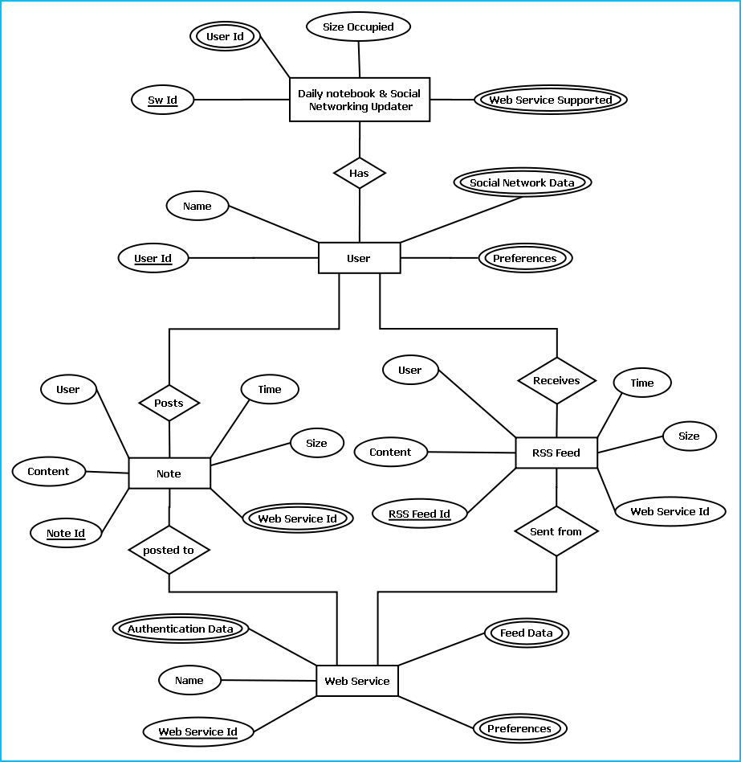

E-R Diagram of Daily notebook & Social Networking Updater

## Class Diagrams/CRC Models/Collaboration Diagrams/Use-case Diagrams/

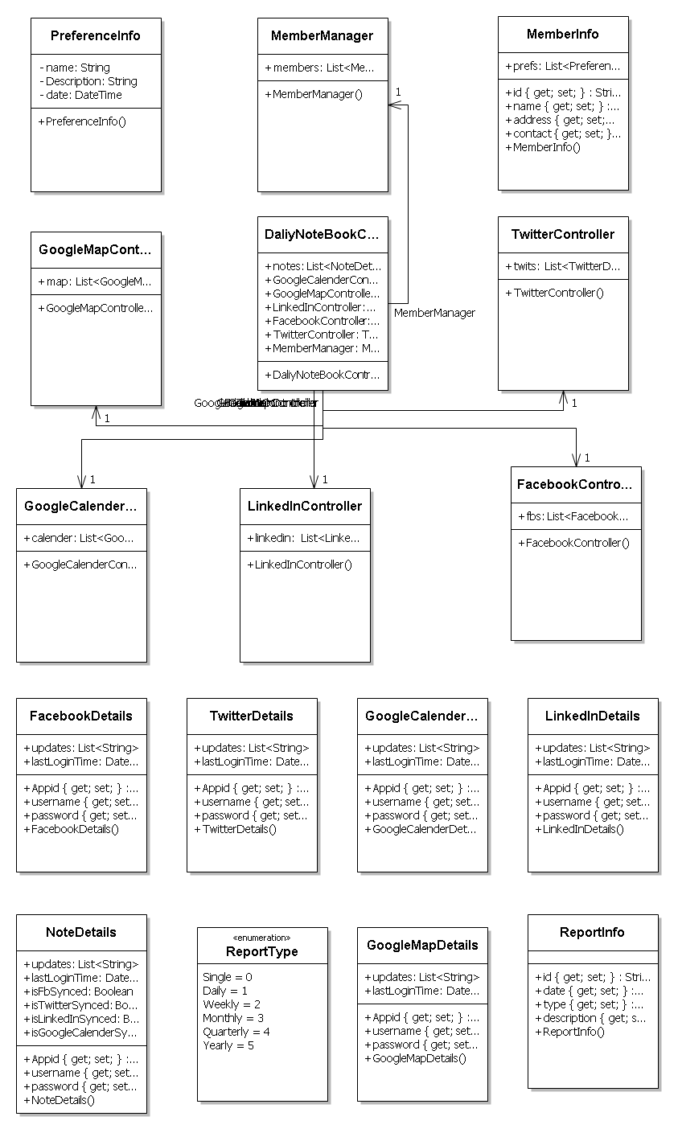

## Activity Diagrams depending upon your project requirements

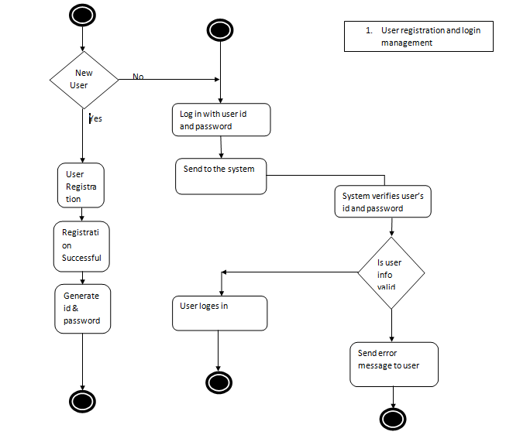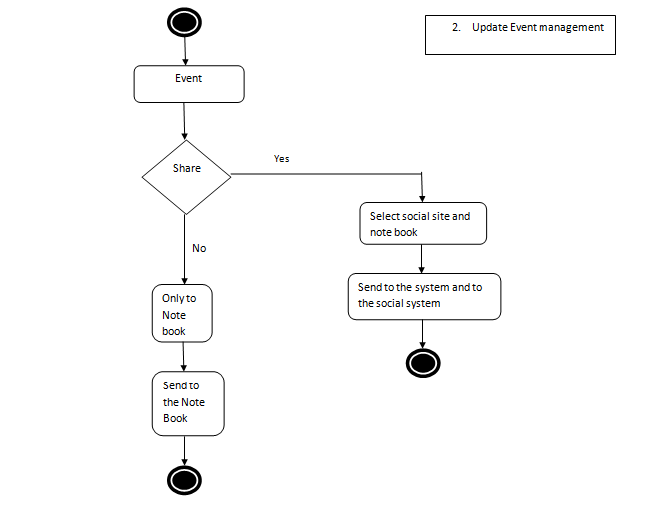

# System Design

## Modularisation details

## Data integrity and constraints

## Database design, Procedural Design/Object Oriented Design

## User Interface Design

## Test Cases (Unit Test Cases and System Test Cases)

# Coding

## Complete Project Coding

## Comments and Description of Coding segments

## Standardization of the coding

12

## Code Efficiency

## Error handling

## Parameters calling/passing

## Validation checks

# Testing

## Testing techniques and Testing strategies used

## Testing Plan used

## Test reports for Unit Test Cases and System Test Cases

## Debugging and Code improvement:

# System Security measures:

## Database/data security:

It encrypts the data stored in the database so that even if someone succeeds to hack the database still not much harm could be done.

The application will use Google open-id authentication for web interface.

## Creation of User profiles and access rights

The software requires a predefined username and password to login.

It allows a guest login as well which lets a guest user user this application with very limited access to the user data.

# Cost Estimation of the Project along with Cost Estimation Model

# Reports (sample layouts should be placed)

* List of Facebook updates could be generated.
* List of twitter update could be generated.
* A list of events could be generated.
* List of LinkedIn update could be generated.
* List of google plus update could be generated.

# Future scope and further enhancement of the Project

* Now it will display the text based RSS feeds and link of the multimedia contents. We will display the Multimedia contents like Video, Audio & Image in future.
* To support UNIX / Linux Based Operating systems.
* To Support Mobile Operating systems for Symbian, Meego & Android.

# Bibliography

* <http://en.wikipedia.org>
* <http://msdn.microsoft.com/en-us/>
* <http://www.microsoft.com/en-us/default.aspx>
* <http://www.codeplex.com/>
* <http://stackoverflow.com/>
* <http://www.codeguru.com/>
* <http://www.w3schools.com>
* <http://blogs.technicise.com/>
* [www.mysql.org](http://www.mysql.org)

# Appendices (if any)

# Glossary.